Name: ____________________________
- Consider the following collision.
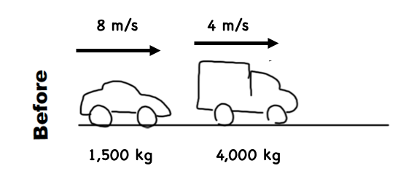

How do we find the velocity of the 4,000kg truck after the collision?

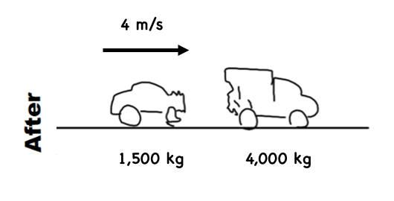
v = ?

Momentum (1,500 kg car)
left = - right = +

=
+
Momentum (4,000 kg car)
left = - right = +

Total Momentum (before)

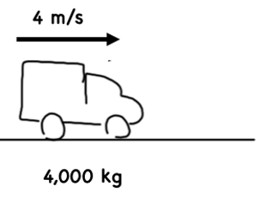
Conservation of Momentum
=

Momentum (1,500 kg car)
left = - right = +

Total Momentum (after)

Momentum (4,000 kg car)
left = - right = +

=
+

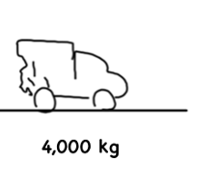
v = ?

Since we know the momentum of the 4,000 kg truck is _____________________, what must its velocity to be?

- Consider the following collision. What is the velocity of the 1,000kg car after the collision?

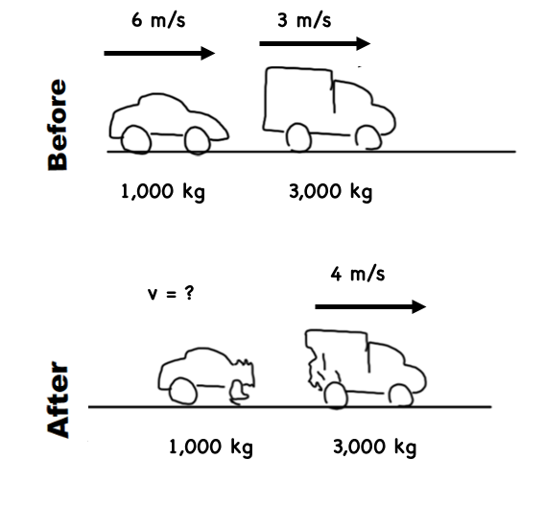

- Consider the following collision. What is the velocity of the 5,000kg truck after the collision? Be careful about direction!
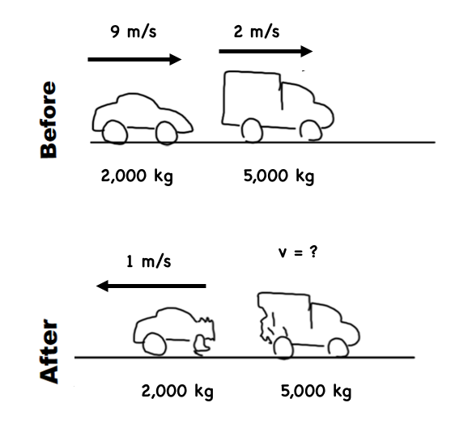

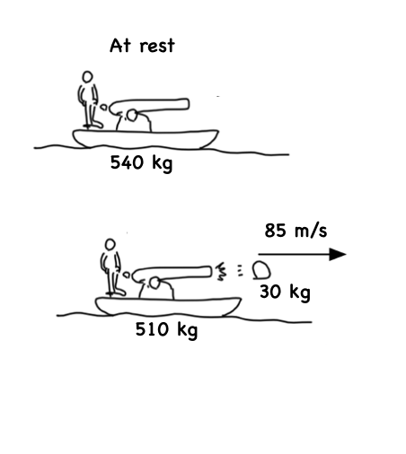
- Consider the following “Third Law-Esc,” situation.

How do we find the velocity of the boat after it launches the cannon?

Momentum (540 kg boat)

Total Momentum (before)

=

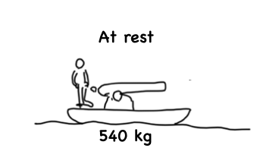

Conservation of Momentum
=

Momentum (30kg cannonball)

Momentum (510kg boat)

Total Momentum (after)

=
+

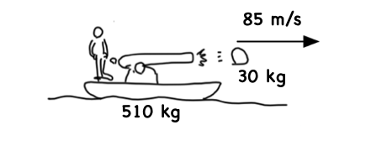

Since we know the momentum of the 510 kg boat is _______________________, what must its velocity to be?

- Consider the following. How fast is the boat moving after it launched the cannonball?

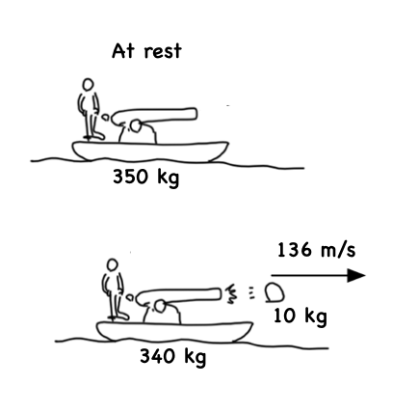

- Consider the following. How fast must the cannonball have been launched?
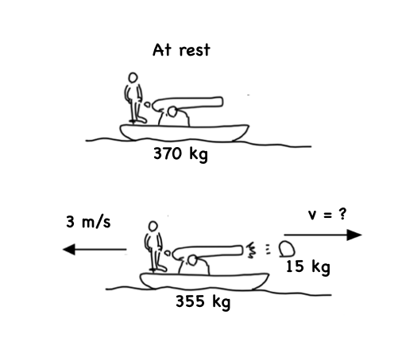

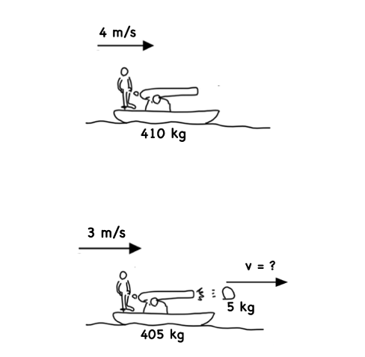
- Find the unknown in the following problems. This is the same setup as the previous 2 questions!

