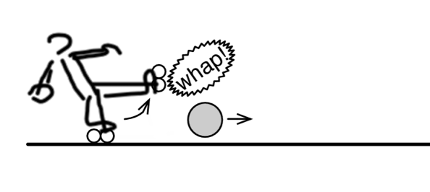
Name: __________________
- The kid kicks a 3 kg ball with a force of 36 N to the right (Assume no drag or friction on the ball)
- What is the acceleration of the ball?

- The kid, whose mass is 48kg, happens to be wearing roller blades with no friction. What is the kid’s acceleration and in which direction?

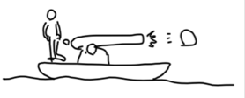

- If the cannon accelerates the 4kg cannonball 100 m/s/s. (Assume no drag or friction on the ball), how much will this 1000kg boat accelerate and in which direction?

- A small car bumps into a big truck that’s at rest in a parking lot. Which vehicles experiences the greater force? Which vehicle undergoes the greater change in acceleration? Defend your answer.

- Jimmy is wearing frictionless roller blades and exerts a 28N force on the wall. He accelerates away from the wall at 0.5 m/s/s. What is Jimmy’s mass?

0.5 m/s/s
