A collision where the masses stick together after the collision is _________________________

and the elasticity is _____________. A collision where the masses fly apart and all the kinetic

energy is conserved is _______________________ and the elasticity is _____________________.

Consider the following collision:
- What is the velocity of the 75kg football player before the collision?

- What is the elasticity of the collision?

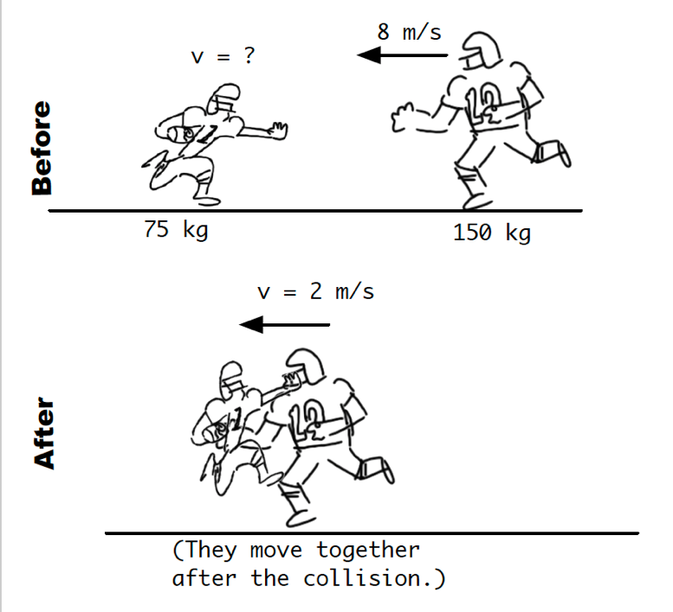

Consider the following collision:
- What is the velocity of the 3,600kg truck after the collision?

- What is the elasticity of the collision?

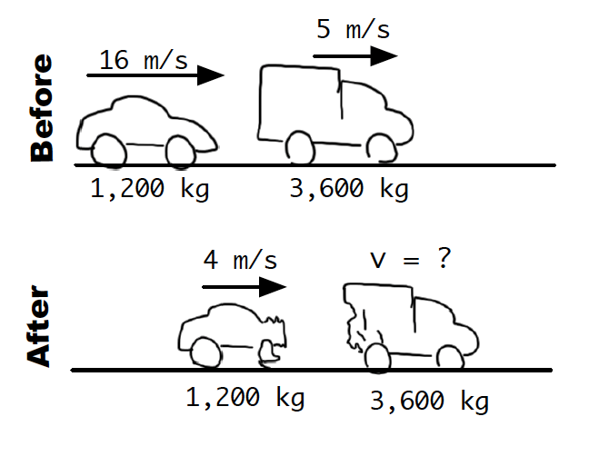

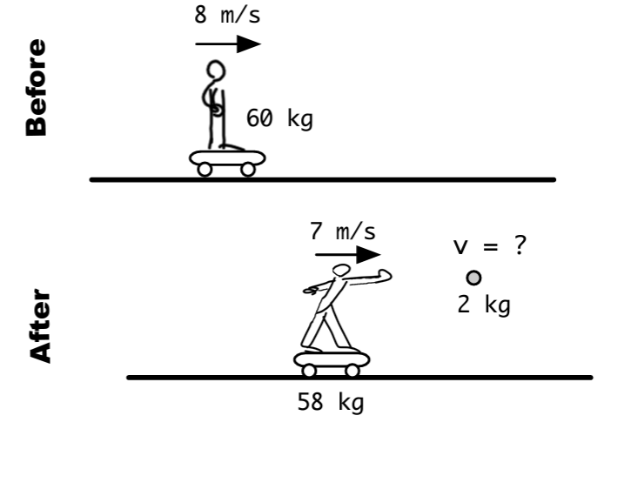
How fast must the person have thrown the 2kg mass?

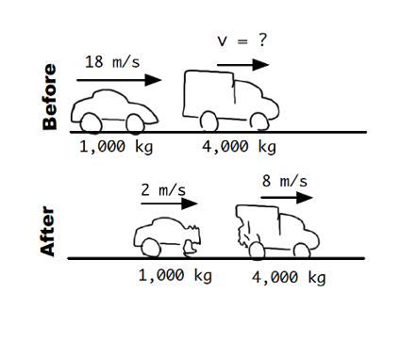
Consider the following collision:
- What was the velocity of the 4,000kg truck before the collision?

- What is the elasticity of the collision?

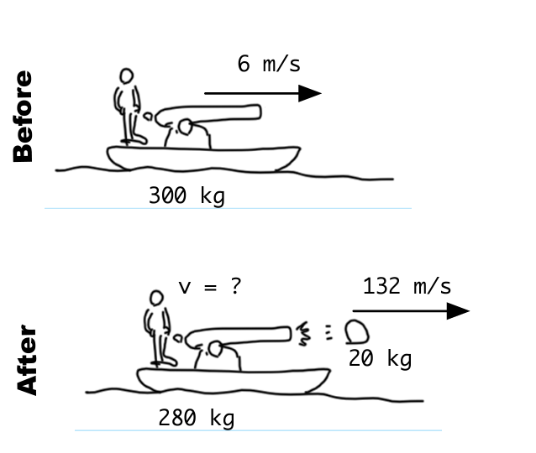
How fast is the boat moving and in which direction after it launched the 20kg cannonball?

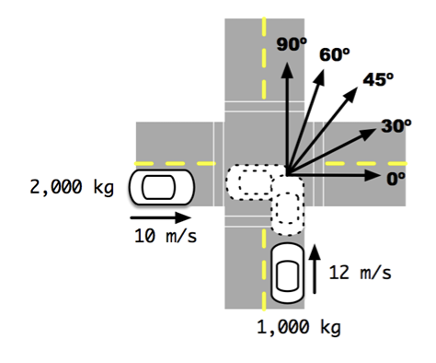
For the collision shown to the right, assuming the vehicles move together after the crash, which is the most likely direction of motion? Explain how you know!

