Name: ___________________

- Consider the following.
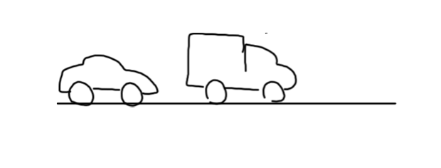
- What is the velocity of the 5,000kg truck after the collision?
- What is the elasticity of the collision?
5 m/s
1 m/s

Before

2,500 kg
5,000 kg

v = ?
2 m/s
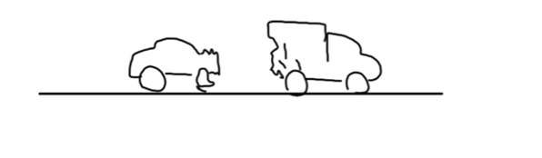

After

5,000 kg
2,500 kg

- What is the velocity of the 1,000kg truck after the collision?
- What is the elasticity of the collision?
- Consider the following.
rest
6 m/s

Before

4,000 kg
1,000 kg

2 m/s
v = ?

After

1,000 kg
4,000 kg

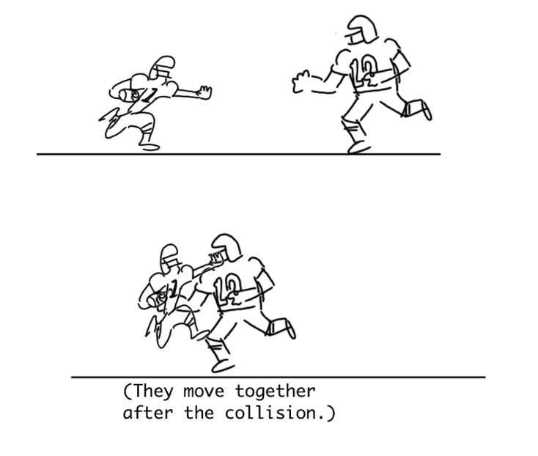
5 m/s
7 m/s
- What is the velocity after the collision?
- What is the elasticity of the collision?

120 kg
80 kg

v =??

??
6 m/s
- What is the velocity of the 150kg player before the collision?
- What is the elasticity of the collision?

150 kg
90 kg
4 m/s

