Name: ________________________
Reaction Time Activity:

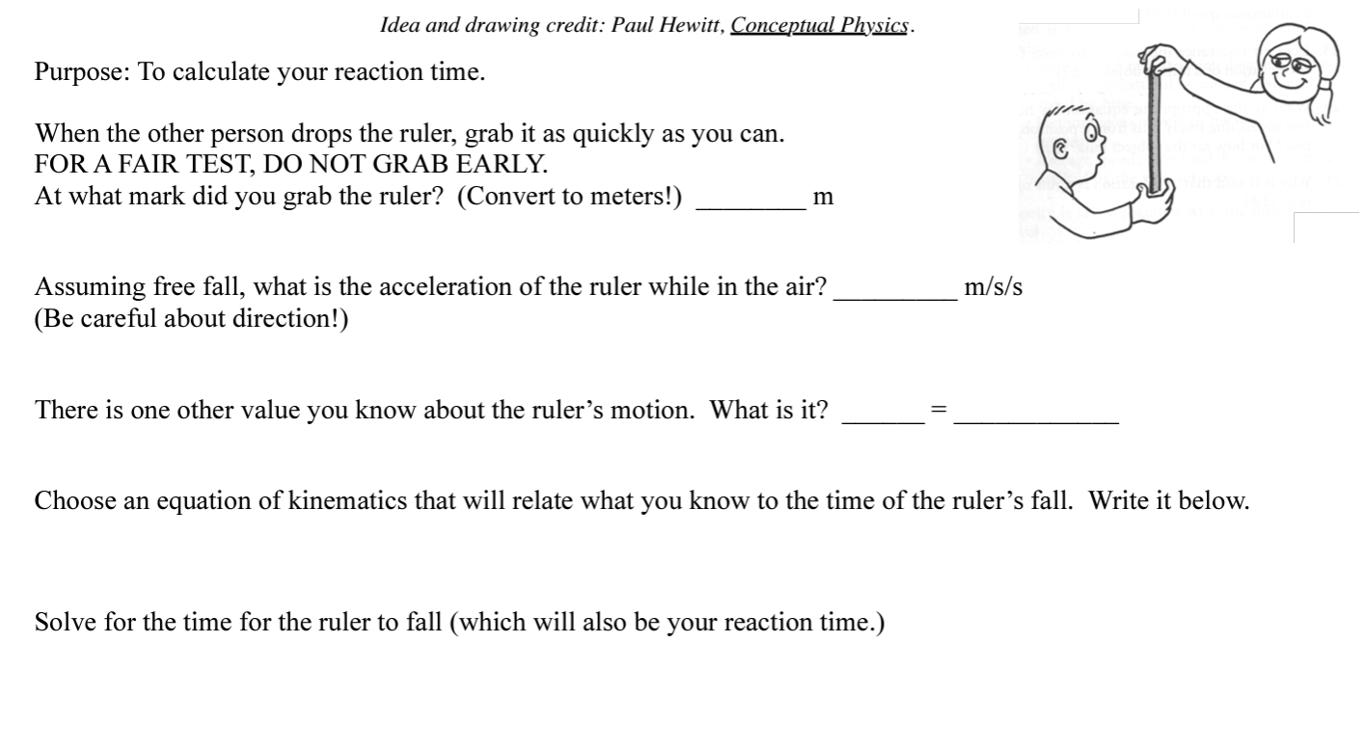

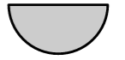

Popper activity:
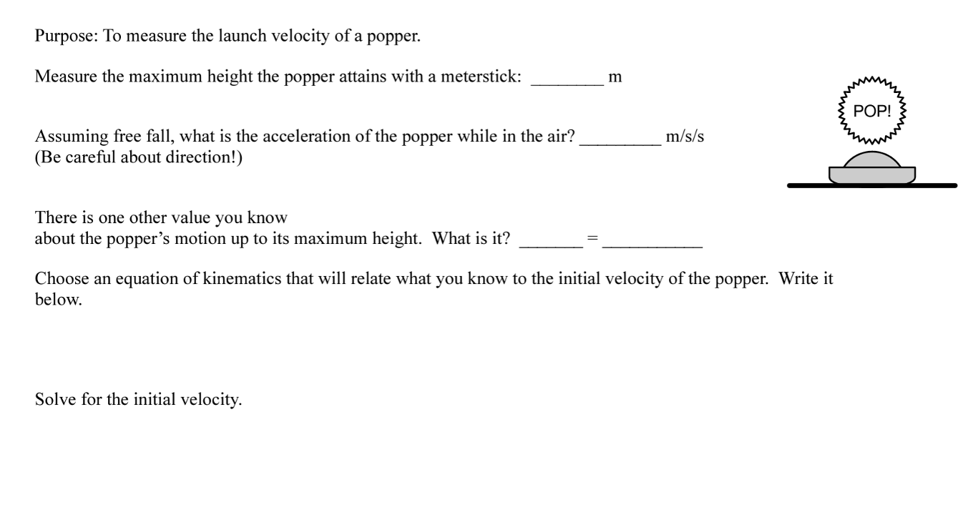

Initial velocity of your roll.

Purpose: To determine how fast you can roll two spheroids of your choice!
Spheroid #2: ________________________

Measure the time it takes for the ball to come to a stop:

Measure the distance the ball traveled before it came to a stop (you’ll have to convert yards to meters!):

What is the third value that you know?

Which kinematic equation should you use? Solve for the initial velocity.
Spheroid #1: ________________________

Measure the time it takes for the ball to come to a stop:

Measure the distance the ball traveled before it came to a stop (you’ll have to convert yards to meters!):

What is the third value that you know?

Which kinematic equation should you use? Solve for the initial velocity.

Challenging: Coefficient of friction between the spheroid and the turf.

Purpose: To determine the coefficient of friction between the spheroid and the turf. We need to use kinematics to find the acceleration of the spheroid, we also need to know the mass of the spheroid as well!

Example: Let’s say that Ellen Ripley rolls a soccer ball with a mass of 400 grams across the turf. The soccer ball travels 65 meters before coming to a stop, and it rolls for 8 seconds. How can we find the coefficient of friction between the ball and the turf?

