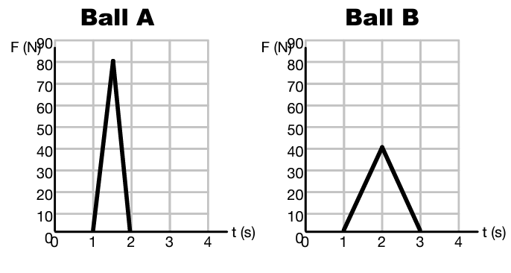
- Two identical Billiard Balls receive the impulse shown in the graphs.

- What can you calculate just from the graphs?

- What can you say about Ball A compared to Ball B?

- A 100kg running back collides with a linebacker going from 6 m/s to 2 m/s.

- What is the change in momentum of the running back?

- What impulse was delivered to the running back?

- If the collision lasted 1.2 seconds, what was the average force delivered to the running back?

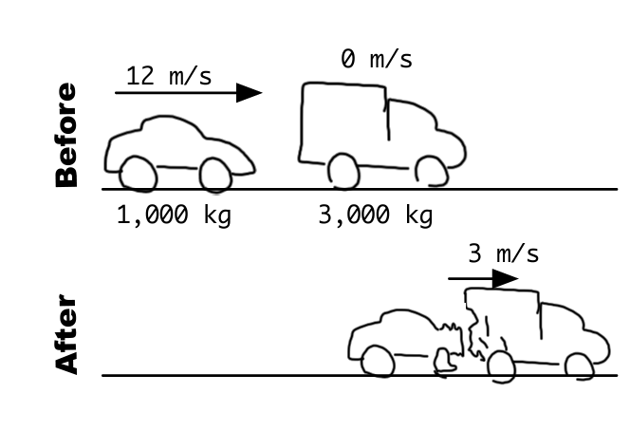
- The car collides with the truck as shown. Afterwards, they move at the same speed.
- What is the change in momentum of the 1,000kg car?

- What impulse was delivered to the car?

- What is the change in momentum of the 3,000 kg truck?

- What was the impulse delivered to the truck?

3,000 kg
1,000 kg

