Name: ________________________

- What variable is used for elasticity? _________________

- What units is elasticity in? ________________________

- What is the equation that determines how elastic a collision is?

- What is the elasticity of the following collision? Round to 2 decimal places!
3 m/s
At rest

Before

4.5 m/s
2.5 m/s


After

- What is the elasticity of the following collision? Round to 2 decimal places!
5 m/s
2 m/s

Before

3 m/s
0.5 m/s
After

- What is the elasticity of the following collision? Round to 2 decimal places!
2 m/s
4 m/s

Before

2 m/s
1 m/s
After

- What was the initial velocity of the 8-ball if the collision was 10% elastic, (k = 0.1)

?? m/s
At rest
Before

6 m/s
5 m/s
After

- Looking at the equation in problem #1, if the “k” value is zero, what would the velocities of the two objects have to be after the collision? Give an example of what this would look like!

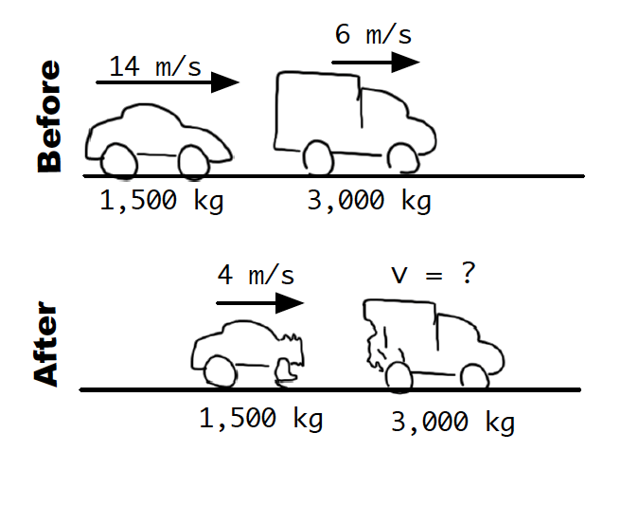
- Connect your knowledge of elasticity to this momentum problem!

Find the velocity of the 3,000kg truck after the collision.

What is the elasticity of this collision?

