Name: ____________________

On a friction graph, what is the coefficient of friction? ___________________________________

What units is the coefficient of friction measured in? ___________________________________
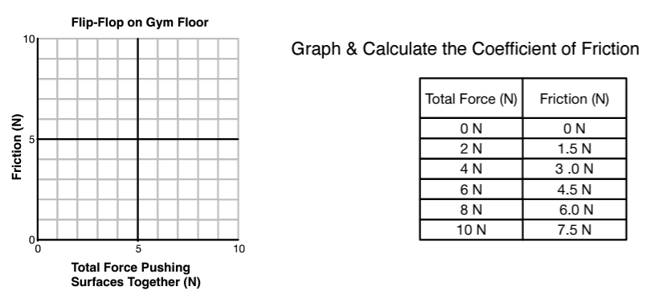

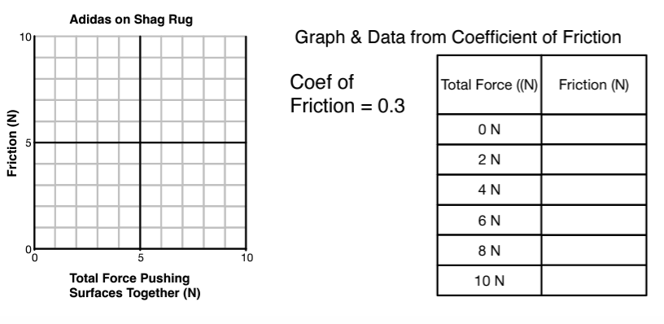

After looking at these graphs, what equation can be used to determine the coefficient of friction?

Using our equation for coefficient of friction, let’s find the coefficient of static friction for the 2kg block if the system below is not moving! Round to 2 decimal places!

2 kg

0.7 kg

Now, you’re going to determine the coefficient of friction of your shoe using the same steps as above!

Mass of your shoe (kg) = ______________________
