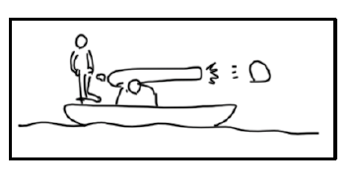
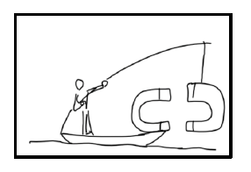
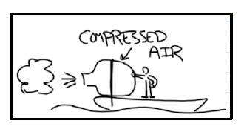
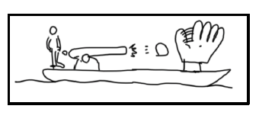
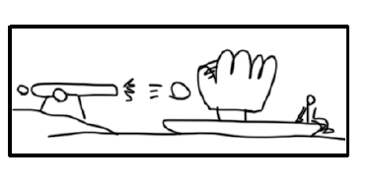
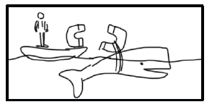
3rd Law Conundrums
3rd Law Conundrums
Situation 2.
You fire a cannonball off the boat.

Situation 1.
You hang a large magnet in front of the boat to attract it forward.

Situation 4.
You attach a large tank of compressed air to your boat and release the air.

Situation 3.
A cannonball is fired from on the boat into a big glove that is also on the boat.

Situation 6.
A cannonball is fired on shore into a big glove on the boat.

Situation 5.
You attach a large magnet to a whale in front of your boat to attract it forward.

Situation 1.
You hang a large magnet in front of the boat to attract it forward.

Situation 2.
You fire a cannonball off the boat.

Situation 4.
You attach a large tank of compressed air to your boat and release the air.

Situation 3.
A cannonball is fired from on the boat into a big glove that is also on the boat.

Situation 6.
A cannonball is fired on shore into a big glove on the boat.

Situation 5.
You attach a large magnet to a whale in front of your boat to attract it forward.

