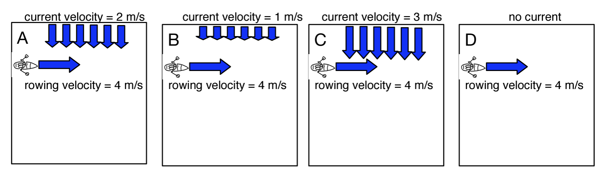

The same boat is rowing at the same velocity across the same river, but the current is different in each case (pictured above). Rank the situations from…

Most time to cross the river to least.

Most _____ _____ _____ _____ Least
Furthest to shortest distance displaced down the river.

Most _____ _____ _____ _____ Least

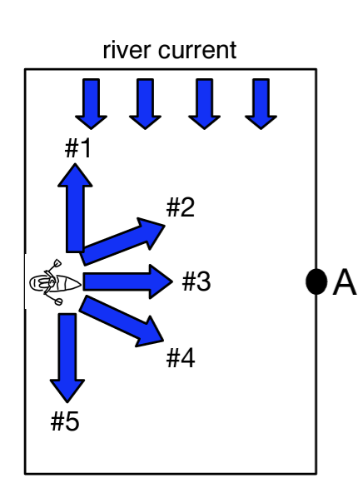

The boat has various choices for crossing the river. Which direction will most likely result in…

- Crossing the river the fastest? Explain.

- Reaching point A? Explain.

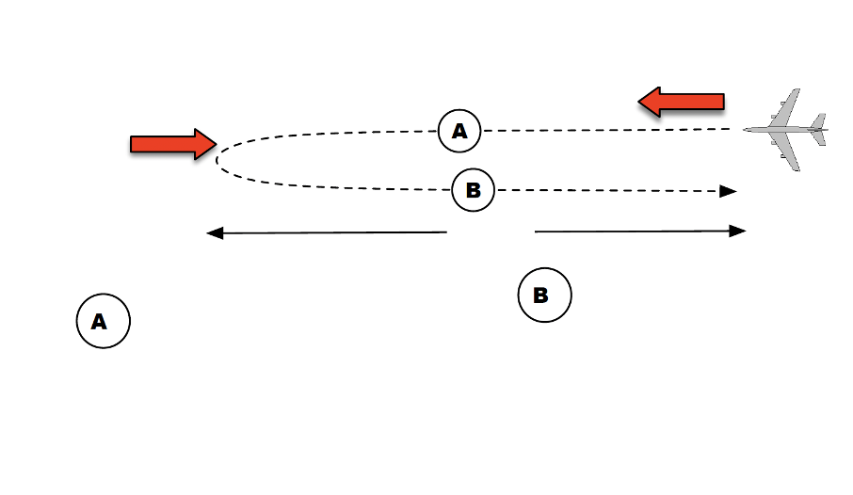
Jet velocity = 125 m/s
Wind velocity = 25 m/s

6000 m

The jet travels against the wind.

Resultant velocity = ________

Solve for the time that part of the journey takes.

The jet travels with the wind.

Resultant velocity = ________

Solve for the time that part of the journey takes.

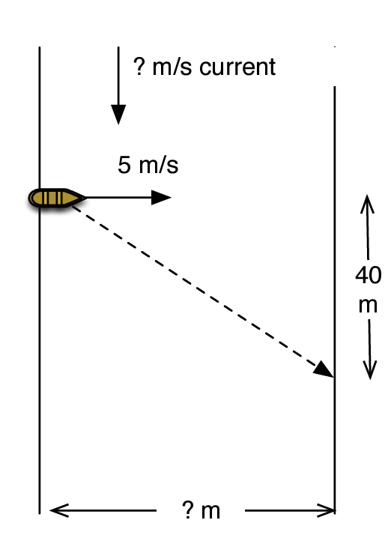

The boat’s velocity is 5 m/s pointed straight across the river. The crossing takes 10 seconds and in that time the current carries the motorboat 40 meters downstream.

- How wide is the river?

- What is the velocity of the current?

