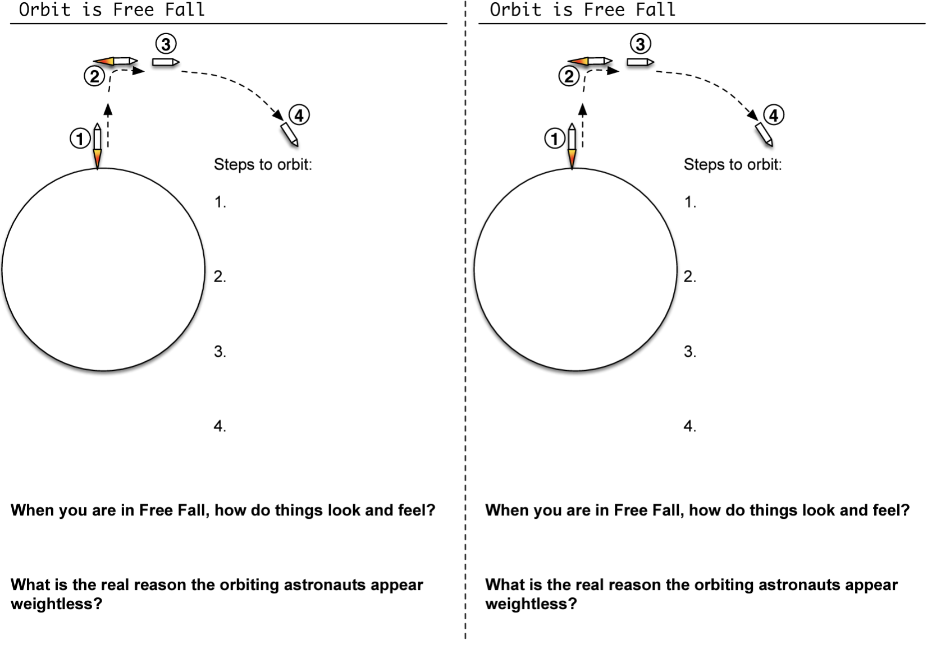
Go onto ‘Cox Concpetual Physics’ and click on “Newton’s Cannon”. Try some different launch speeds.

What is the minimum speed that worked to get your object into orbit?

Was it a perfect circle?
Go onto ‘Cox Conceptual Physics’ and click on “Newton’s Cannon”. Try some different launch speeds.

What is the minimum speed that worked to get your object into orbit?

Was it a perfect circle?
Name: ______________
Name: ______________

