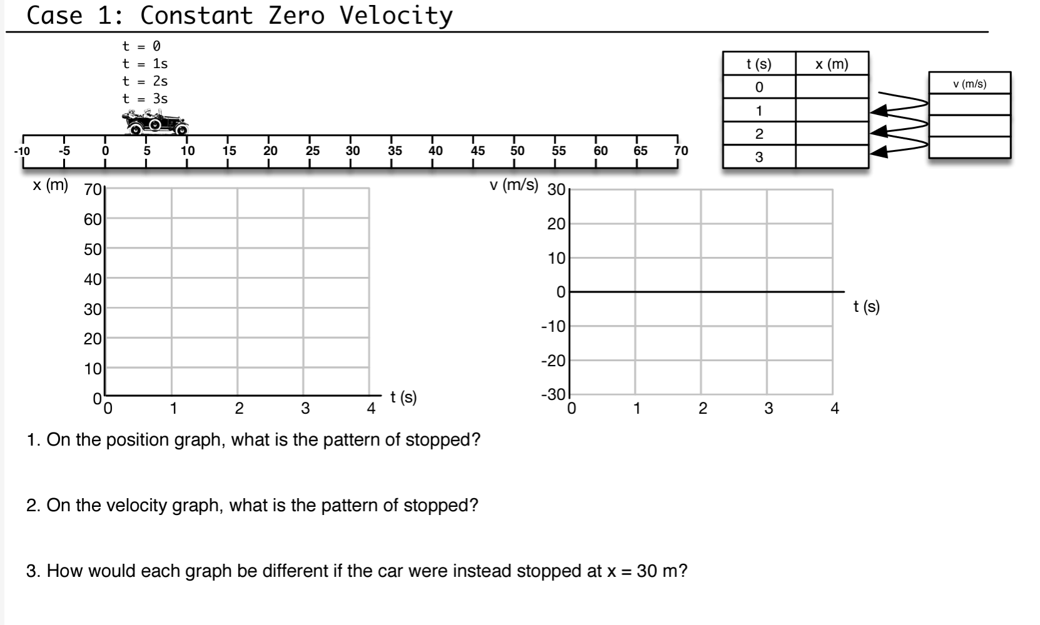

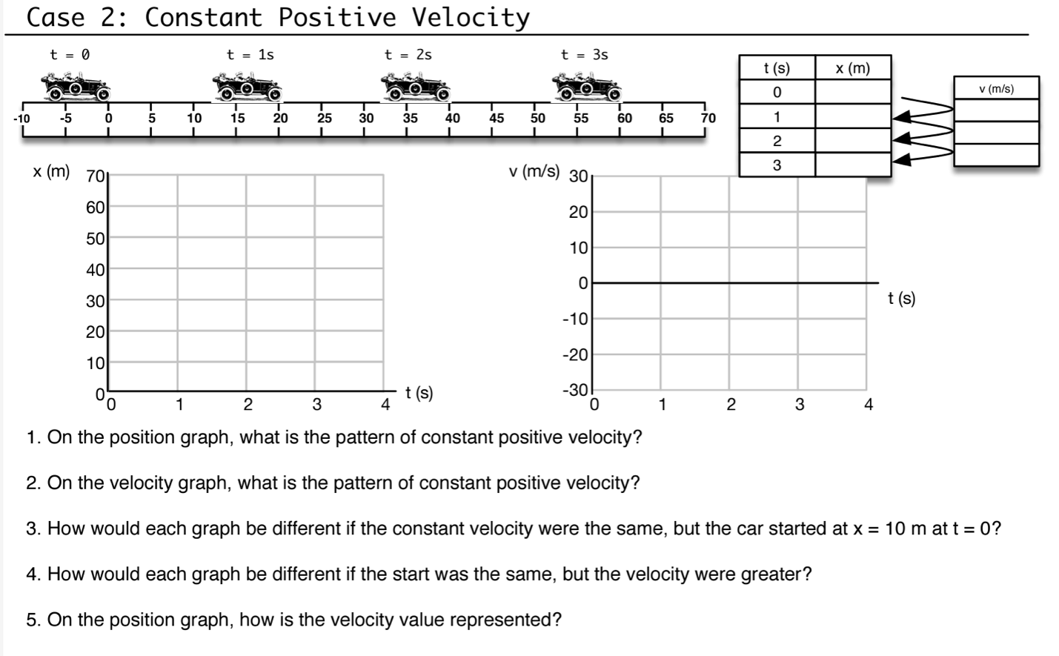

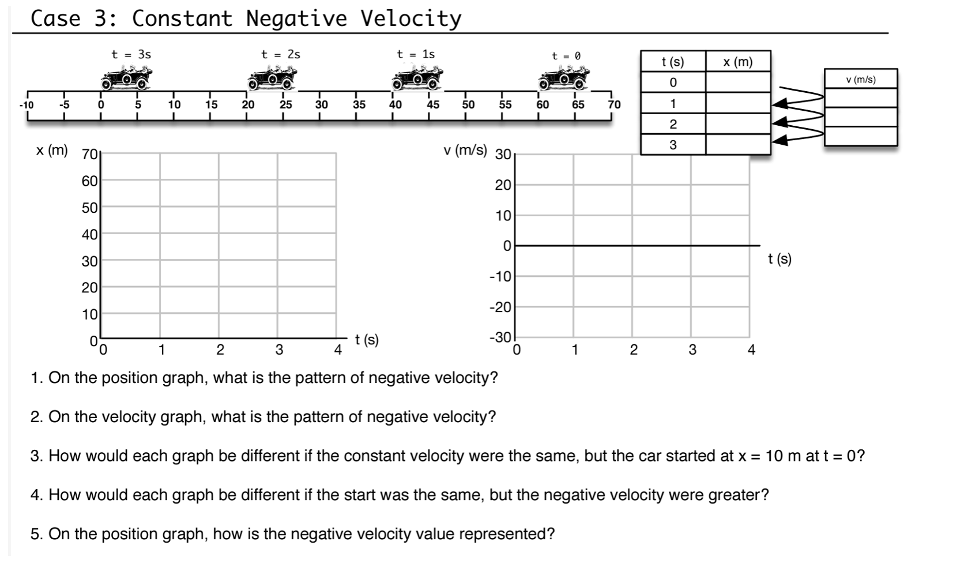

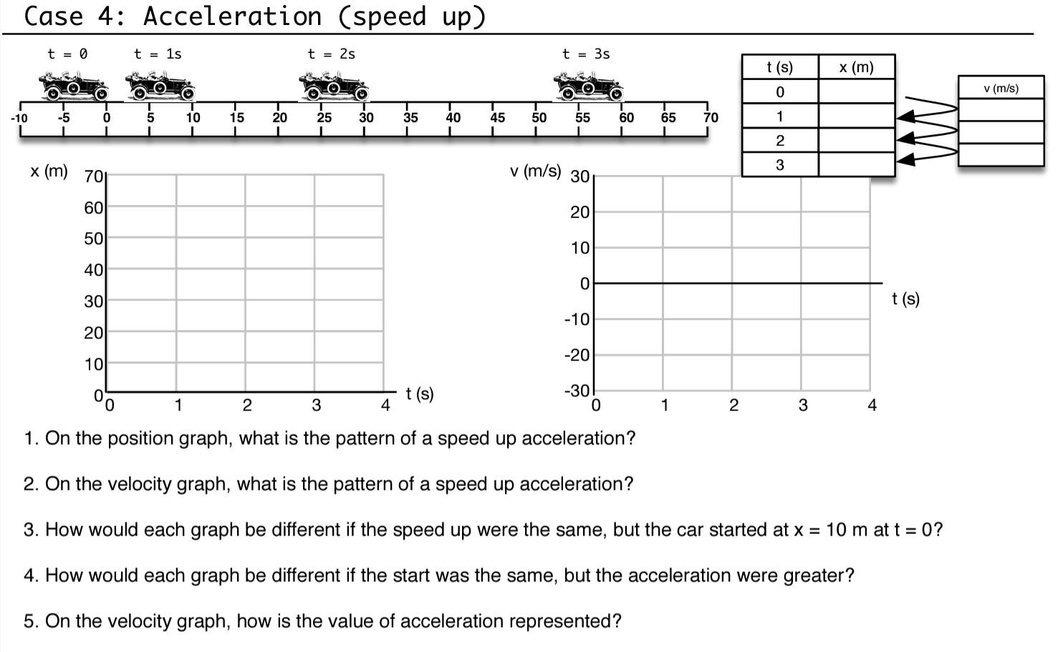

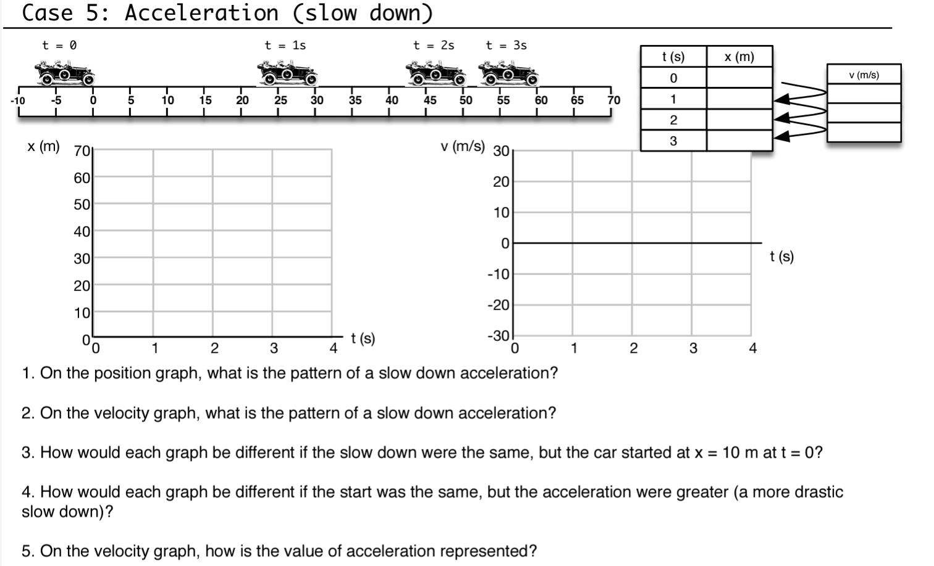

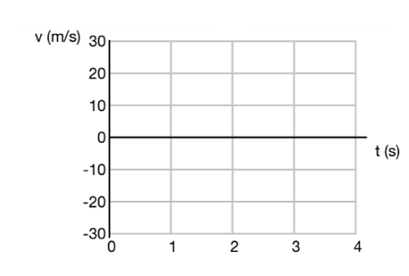
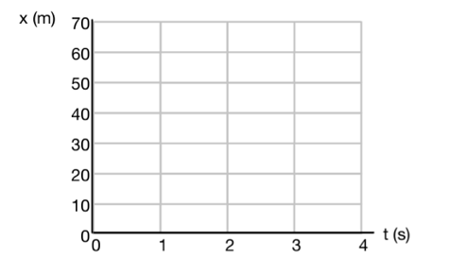
Match the pattern with the type of motion that is present.
- Stopped
- Constant Velocity (moving right)
- Constant Velocity (moving left)
- Acceleration (speed up to the right)
- Acceleration (slow down to the right)
Look at the position graph and sketch out what the velocity graph looks like. Also provide a brief description of what happens for each time interval (direction, velocity, turn-arounds, etc.).
Compound Constant Velocities
