Name: ________________________
With the dot patterns below, determine what kind of motion is present, and compare the magnitude of the two motions. Assume each dot is one second passing. Fill out the tables.
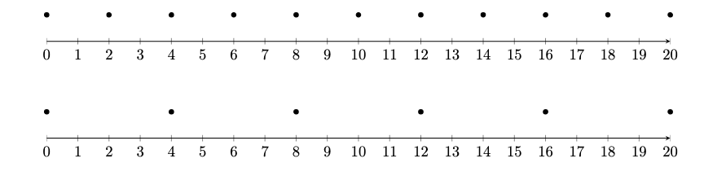
A
Position (m)

B
Position (m)

B
Time (s) | Position (m)
0
1
2
3
4
5

A
Time (s) | Position (m)
0
1
2
3
4
5

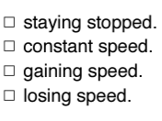
What kind of motion are A AND B representing (Check one)?

Which one is higher and by how much? ________________
A
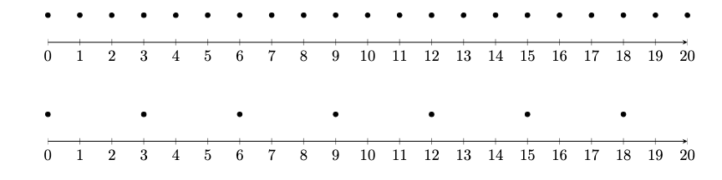
Position (m)

Position (m)
B

A
Time (s) | Position (m)
0
1
2
3
4
5
6

B
Time (s) | Position (m)
0
1
2
3
4
5
6

What kind of motion are A & B representing (Check one)?

Which one is higher and by how much? ____________________
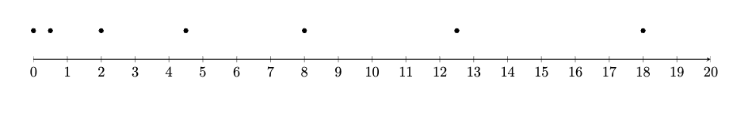
Position (m)
A

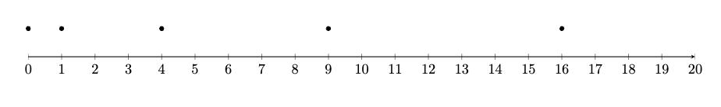
B
Position (m)

A
Time (s) | Position (m)
0
1
2
3
4

B
Time (s) | Position (m)
0
1
2
3
4

What kind of motion are A & B representing (Check one)?

Which one is higher and by how much? _______________

A
Position (m)

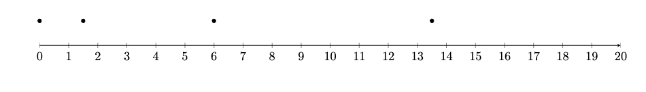
Position (m)
B

B
Time (s) | Position (m)
0
1
2
3

A
Time (s) | Position (m)
0
1
2
3

What kind of motion are A & B representing (Check one)?

Which one is higher and by how much? _________________

