Name: _____________________
Forces as components

Let’s say that we have a force pointing in the following direction. We can determine the force’s x and y components by doing the following.
+y
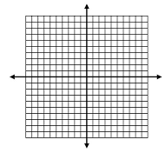

$$F_{x}$$ | $$F_{y}$$
-x
+x

-y

Sketch the x and y components. Estimate their size by counting the spaces. Include appropriate sign!
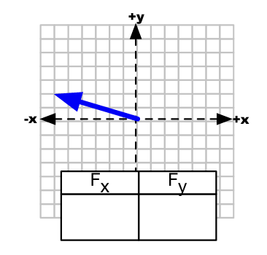
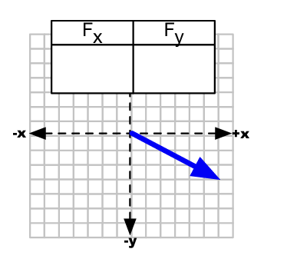
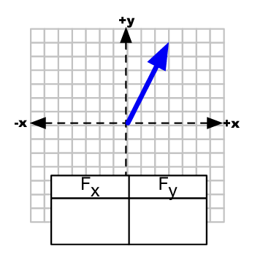

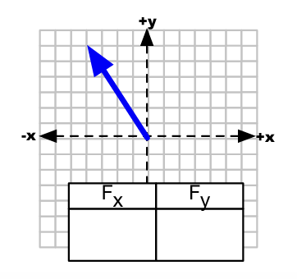
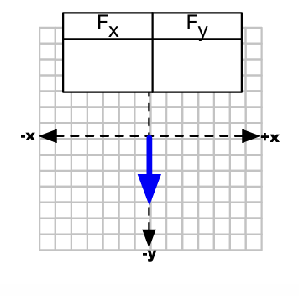
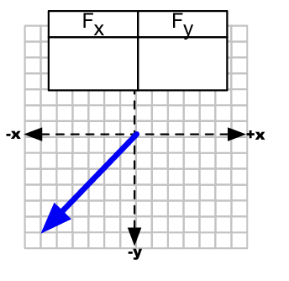

$$+y$$

$$-x$$
$$F$$
$$+x$$

$$θ$$


$$-y$$

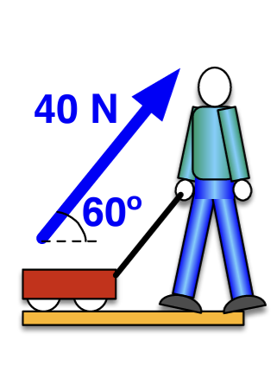
Sketch the x and y components. Calculate their size using Trig. Don’t worry about $F_{G}, F_{N}, or F_{f}$ yet!
$$+y$$
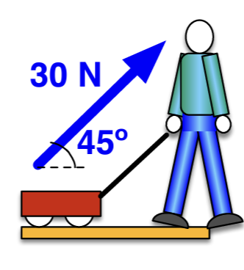
$$+y$$

$$+x$$
$$-x$$
$$+x$$
$$-x$$

$$-y$$
$$-y$$

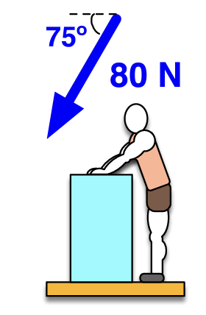
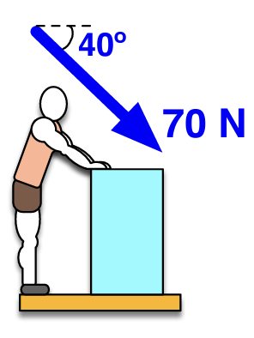
$$+y$$
$$+y$$

$$-x$$
$$-x$$
$$+x$$
$$+x$$

$$-y$$
$$-y$$

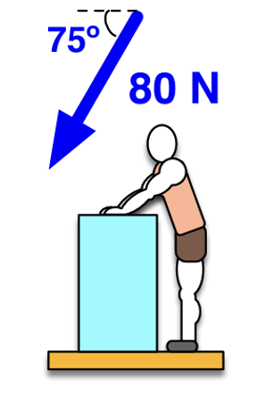
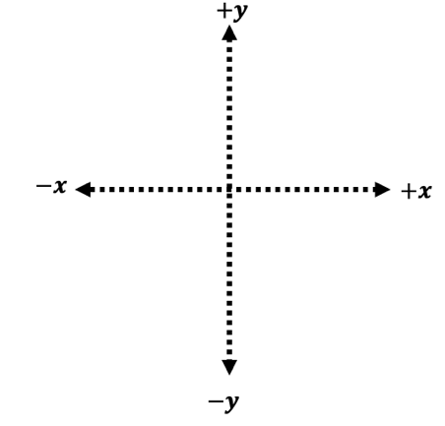
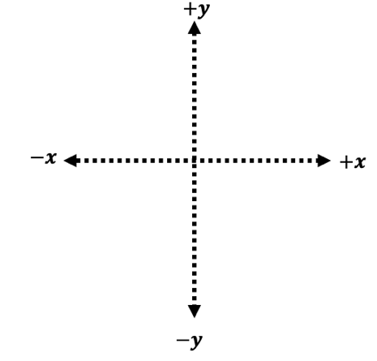
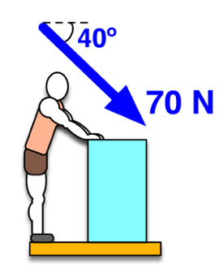
90 N

80 N

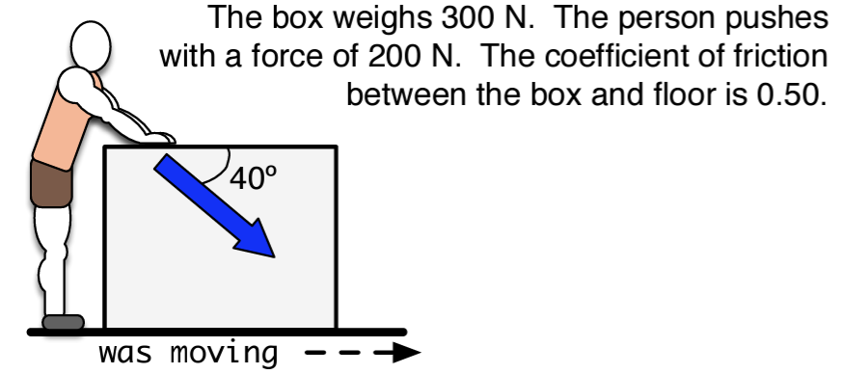

This box will only be moving right or left, NOT up or down!

- Draw and label all force on the diagram, including components.
- Find the normal force.
- Find the Force of Friction
- Find the net force in the x-direction.

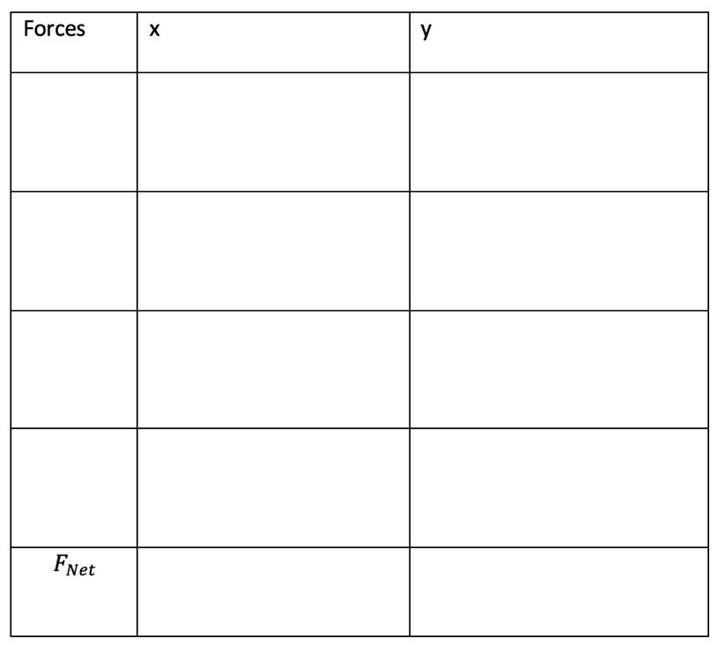

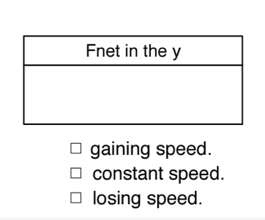
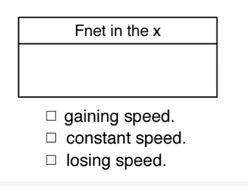

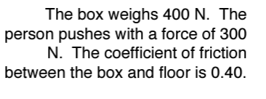
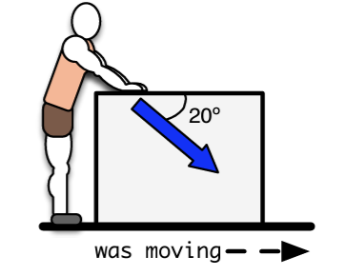

This box will only be moving right or left, NOT up or down!

- Draw and label all force on the diagram, including components.
- Find the normal force.
- Find the Force of Friction
- Find the net force in the x-direction.

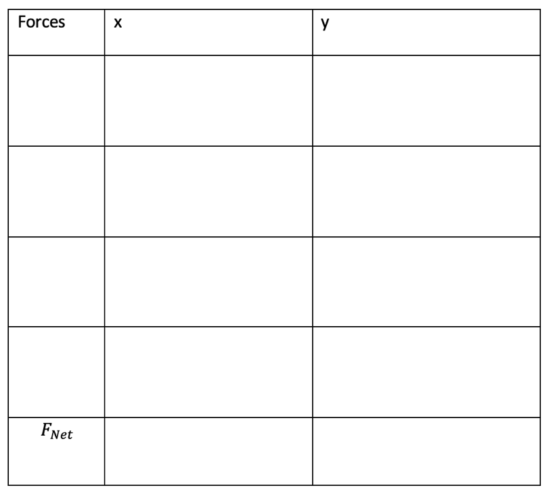

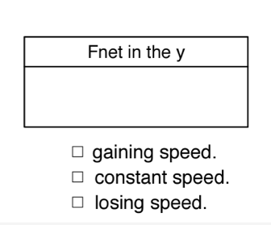

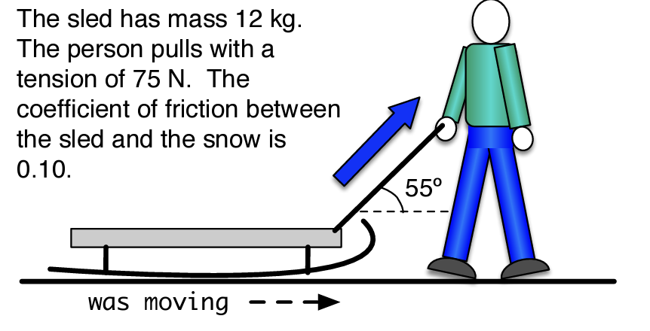

This sled will only be moving right or left, NOT up or down!

- Draw and label all force on the diagram, including components.
- Find the normal force.
- Find the Force of Friction
- Find the net force in the x-direction.

